Director’s Report
Prepared by Donita Ward: December 2025
Attachments: posted to website
- Agenda
- Statistics & Digital Statistics
- Balance Sheet
- Profit and Loss Report
- Draft minutes from previous meetings
- Sales Tax collection and trends report from HDL

Budget Adjustment Requests and Financial Items for Approval:

- See agenda
Policy Updates:
- None for this meeting
Finance & Administration
Sales tax income remains strong. There have been substantial fluctuations through the year, more so than usual, but our end collections are on target. The snapshot from HdL is posted to the website and the full confidential report will be available at the meeting.
We are under contract with Gary Davis at West Davis for the FY2025 Financial Audit as required by statute. It’s going to be a bit more involved than years previous, so I’m glad we have an auditor familiar with our systems to keep an eye on everything.
Outreach & Branding
Luminaries is our next big event for community outreach. I’m excited to attend as we’ve not been able to in years past. Nick is going to read stories both nights.
Lauren was at the Wells Branch Elementary Academic Night on November 4 and will be back for Lumos on December 11. Dayna is going to visit the Silver Branchers and talk about library offerings to that group as well, which we haven’t been able to get into previously.
The frog naming process is well underway. We got seventy-three suggestion slips, which I consolidated into surveys. I think people are having fun with it.
One aspect of outreach that has come unexpectedly from our renovation is the reallocation of items. The cabinets from our catering kitchen next door as well as some of the appliances have been donated to Habitat for Humanity. The folding tables and chairs went to the Wells Branch Elementary PTA. Smaller things like side chairs and poster frames have been given out on the Buy Nothing (now Give Freely) neighborhood group.
Operations
Inventory for October was the Adult Fiction section. We were able to locate all but 20 of the 9432 items, which is a 0.21% loss or shrinkage rate. That’s a very low number, indicating that we actually have and can lay hands upon almost everything we think we should have.
Karen went through all the cancelled purchase order items and get us to a good starting point from the loss of Baker and Taylor. We then reordered using Brodart. Our first batch of POs to Brodart was for 1171 books. Many have arrived and we are tweaking our processing rubric with the distributor. There is a significant delay when we have to re-process and/or create new MARC records for items that have arrived and are not ready to deploy. That said, everyone is working hard to get these items to the shelves and we should have the system working more smoothly for our next set of orders in January.
Another casualty of the Baker and Taylor closure was Boundless, the EBook library curated by the Texas State Library. We are fortunate in that our patrons have access to Libby and Hoopla thanks to our healthy budget and generous allocation of funds to those services. There are libraries that used Boundless as their one and only digital library and those patrons are now without.
Internal Affairs
CPR training was completed for staff at the October inventory. We have twelve persons certified to do first aid, CPR, and use the AED for adults, children and infants. Hopefully, they are not called into action at the library.
The notary renewal process is a bit more arduous than I expected, but I have completed it. I also took a refresher online course. The Secretary of State issues certificates of commission and there is a nearly month-long delay (backlog?) on that step. We have four more people who agreed to become notaries and have started the process. I asked additional assistant managers who work evenings and weekends to become notaries and many accepted, so we should have expanded availability once all the paperwork goes through.
I completed End of Year Strategy Sessions (previously known as the annual performance evaluations) for each member of staff and they were all happy and grateful for the wage bump and bonuses.
The temporary/substitute worker system didn’t turn out as well as we’d hoped. After a few weeks (and some blow-back at the end), the managers and I determined that we are better served with volunteers and multi-tasking.
I attended the Texas Library Association District 3 meeting in Temple, which was followed immediately by a council meeting. Everything in library land is going pretty much as expected and we remain a lucky outcast as a Library District in that we can stay out of political silliness. Nick and I went to the PLAN Performer Showcase in Georgetown where we saw some great options to hire for our new space when it becomes available.
I’ve created a draft suggested org chart with new job titles.
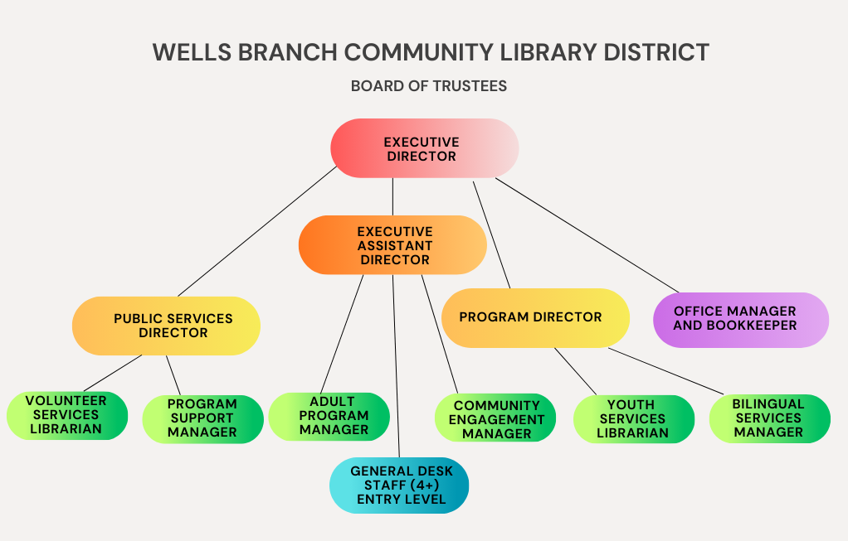
Technology
Eventually, Katrina was able to get all the little bits of the servers to work despite the TFE support staff turnover. Shortly thereafter, the shared files got unmapped from a Microsoft update. We found a workaround. On the horizon (phase 4 of renovation when we move and replace the patron machines) it is probably time to move away from Microsoft and to an open office or google office platform.
This month we also need to update our SonicWall (router with base filtering and firewall) and Faronics (deepfreeze and antivirus) licenses. Both renewals are in process.
Facilities
Library Interiors came out last month to re-measure our shelves and collection. I got them all the numbers involving the materials we own and what we expect to own along with how much is generally on the shelves at any given time. They are going to rework the shelving configurations to make sure we have enough actual bookshelves to house our collection.
We have repairs scheduled this month for the HVAC heat check and some sprinkler head leaks. Both are regular occurrences. We had an issue with the alarm system where a motion sensor was broken and preventing the alarm setting at night. That’s been resolved.
When we lose the front door and have an alternate entrance, we are going to have to move a workstation to that area. We are going to need to add a monitoring point to that door so it’s part of the security alarm system. A new workstation location means moving a phone extension as well. Even though it’s temporary, it needs to be fully functional. There are a lot of dominoes that need to fall into place with each phase of work, and there are likely to be some unanticipated bumps in the road, but we are all trying to stay ahead of anything that would be a pain point for the patrons. Patron problems translate exponentially into staff problems.
Programs
Winter Reading is upon us. We have the cutest cooking themed prizes. Adults (or older kids) can earn a wooden spoon and tea towel with our chef frog printed upon them. Younger readers will get a bag with a little rolling pin, cookie cutter, and play doh. This is all to tie into our cookbook.
Kids programs are going strong. Wiggle worms remains our most popular, but the bilingual offerings and Sign Language are not far behind. Teen library council consistently gets double digit attendance. There were 22 TEENAGERS at the library after dark program, a huge success for that age group. We will offer it again in February.
Adults are working with the restricted space and adapting to the dual offerings. Terrarium pendants was especially well attended. We noticed in 2024 that the First Friday Cultural programs were not as popular as we’d hoped. We regularly had less than 10 attendees and these performers average $300 per event. Once we have the space available again, we are going to try a new time slot in the hopes of bringing in more people. Those programs are more expensive to provide, so we need better turnout.
Wells Branch as a neighborhood is still very heavily weighted to arts and crafts for anyone big enough to hold a crayon and music and stories for the smaller crowd. Passive programs, especially the selection bulletin boards, are doing very well. Our people like to vote by sticker. I don’t know why.

